**PIZZA SALES SQL QUERIES**

1. **KPI REQUIREMENT**

i. Total Revenue

ii. Average Order Value





iii. Total Pizza Sold





iv. Total Orders





v. Average Pizzas per Order

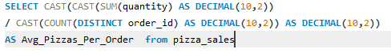



1. **DAILY TREND FOR ORDERS**

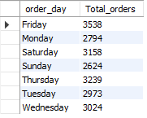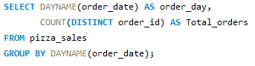

1. **MONTHLY TREND FOR ORDERS**

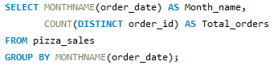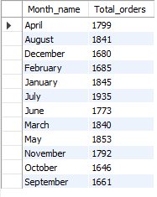

1. **% SALES BY PIZZA CATEGORY**

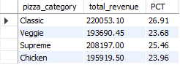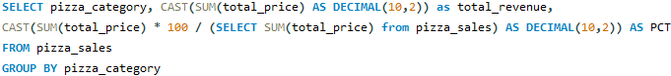

1. **% SALES BY PIZZA SIZE**

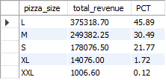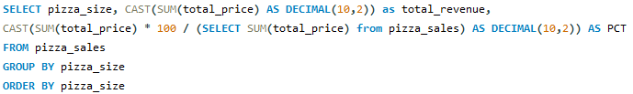

1. **TOTAL PIZZAS SOLD BY CATEGORY**

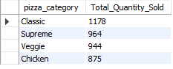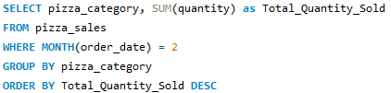

1. **TOP 5 PIZZAS BY REVENUE**

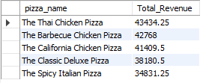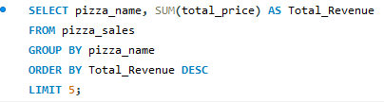

1. **BOTTOM 5 PIZZAS BY REVENUE**

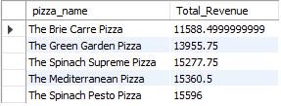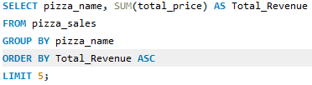

1. **TOP 5 PIZZAS BY QUANTITY**

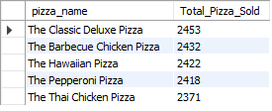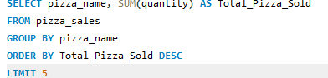

1. **BOTTOM 5 PIZZAS BY QUANTITY**

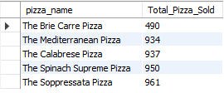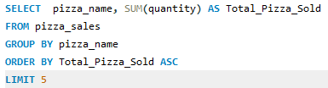

1. **TOP 5 PIZZAS BY TOTAL ORDERS**

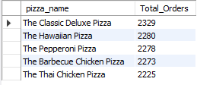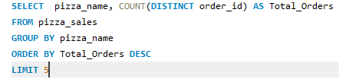

1. **BOTTOM 5 PIZZAS BY TOTAL ORDERS**

